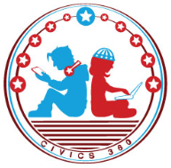
Engaged Citizens: SS.7.C.2.13
Examining Multiple Perspectives
VIDEO VIEWING GUIDE #1
Name: ________________________________

Date: _________________________________
Groups That Influence Public Perspectives Video #1
Question | List Specific Evidence from the Video | Complete Sentence
1. What is meant by the term ‘multiple perspectives’?

2. How does the First Amendment protect our right to express our views?

3. Define each term in relation to how it influences multiple perspectives on issues. | Interest Groups:
 | Political Parties:
 | Individuals:
4. Describe some ways in which individuals, interest groups, and political parties can make their multiple perspectives known.
5. What are some different ways that the First Amendment allows us to share multiple perspectives?

Extra Notes Section

