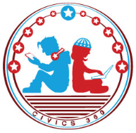
The U.S. & The World: SS.7.CG.3.1
Forms of Government
VIDEO VIEWING GUIDE #1
Name: ________________________________

Date: _________________________________
Forms of Government Video #1: Republic, Direct Democracy, Oligarchy
Question | List Specific Evidence from the Video | Complete Sentence
1. What is meant by the phrase ‘form of government’?

2. Explain the three basic powers of all governments. | legislative power
 | executive power
 | judicial power
3. How do we define ‘republic?
4. What is another name for a republic?
5. How is power limited in a republic?

6. How does a direct democracy differ from a representative democracy?
7. How is Florida’s amendment process an example of direct democracy?
8. How do we define ‘oligarchy’?
9. What is an example of an oligarchy?

Practice: For each of the scenarios below, identify the type of government being described.
Scenario | Type of Government
In the United States, citizens elect representatives to federal, state and local government positions. These representatives make decisions for the people.
In Russia after the collapse of the Sovie Union, many of the most important decisions are made by a small group of very wealthy people.
Some Native American tribes organize themselves by having all male adult members of the tribe vote to make changes to the laws.

