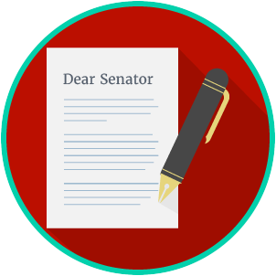
Name: ________________________

Date: _________________________
Engaged Citizens: SS.7.C.2.12
Public Policy
Problem Solving
READING GUIDE #3
Reading: Analyzing Public Policy Alternatives

Benchmark Clarification 3: Students will analyze public policy alternatives to resolve state and local problems.

Reading Task | Response
What ideas are presented in the reading?
What is the central idea of the reading?
Select two words or phrases that support the central idea.
How might this reading connect to your own experience or something you have seen, read, or learned before?
Why do you think it is important to find alternative solutions to state and local problems? | It is important to find alternative solutions to state and local problems because:

