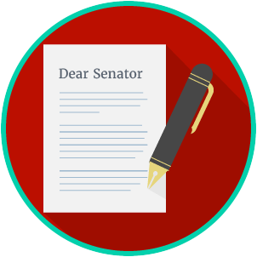
Name: ________________________

Date: _________________________
Engaged Citizens: SS.7.C.2.12
Public Policy
Problem Solving
VOCABULARY PRACTICE

Public Policy Problem Solving

Write about your understanding of public policy by explaining the connections between and among each of the terms in the concept circle.

How do the terms in the concept circle fit together?

