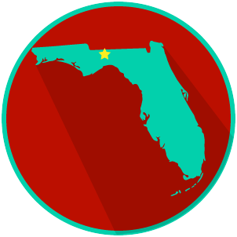
FL State & Local Government:
SS.7.C.3.8/C.3.9
Structure, Powers & Processes of State & Local Government
READING GUIDE #1
Name: ______________________

Date: _______________________

Reading: The Processes of the Three Branches of Government

Benchmark Clarification 1: Students will examine the processes of the legislative (e.g., how a bill becomes a law, appointment confirmation, committee selection), executive (e.g., executive order, veto, appointments), and judicial (e.g., judicial review, court order, writ of certiorari, summary judgment) branches of government.

Reading Task | Response
What ideas are presented in the reading?
What is the central idea of the reading?
Select two words or phrases that support the central idea.
How might this reading connect to your own experience or something you have seen, read, or learned before?
Summarize the processes of ONE of the branches of government you read about, in your own words.

