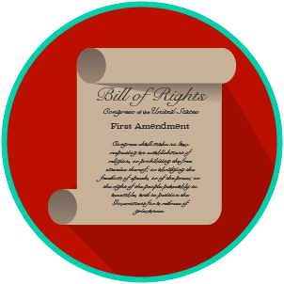
Name: _______________________

Date: ________________________
My Rights & Liberties: SS.7.C.3.7
Voting Rights
READING GUIDE #2

Reading: The Impact of Voting Rights

Benchmark Clarification 2: Students will evaluate the impact these amendments have had on various social movements.

Reading Task | Response
What ideas are presented in the reading?
What is the central idea of the reading?
Select two words or phrases that support the central idea.
How might this reading connect to your own experience or something you have seen, read, or learned before?
Describe how two of the amendments you read about have impacted social movements. | Two amendments that impacted social movements are the ________  and the ________Amendments. They impacted them by:

