Why a Constitutional Republic?: SS.7.CG.3.2
Systems of Government
READING #2
Name: ________________________

Date: _________________________

SS.7.CG.3.2 Benchmark Clarification 2: Students will compare the organizational structures of systems of government.

System of Government | Example | Model
Federal | Power is shared and divided between the central government and states. Citizens elect officials at all levels of government. | 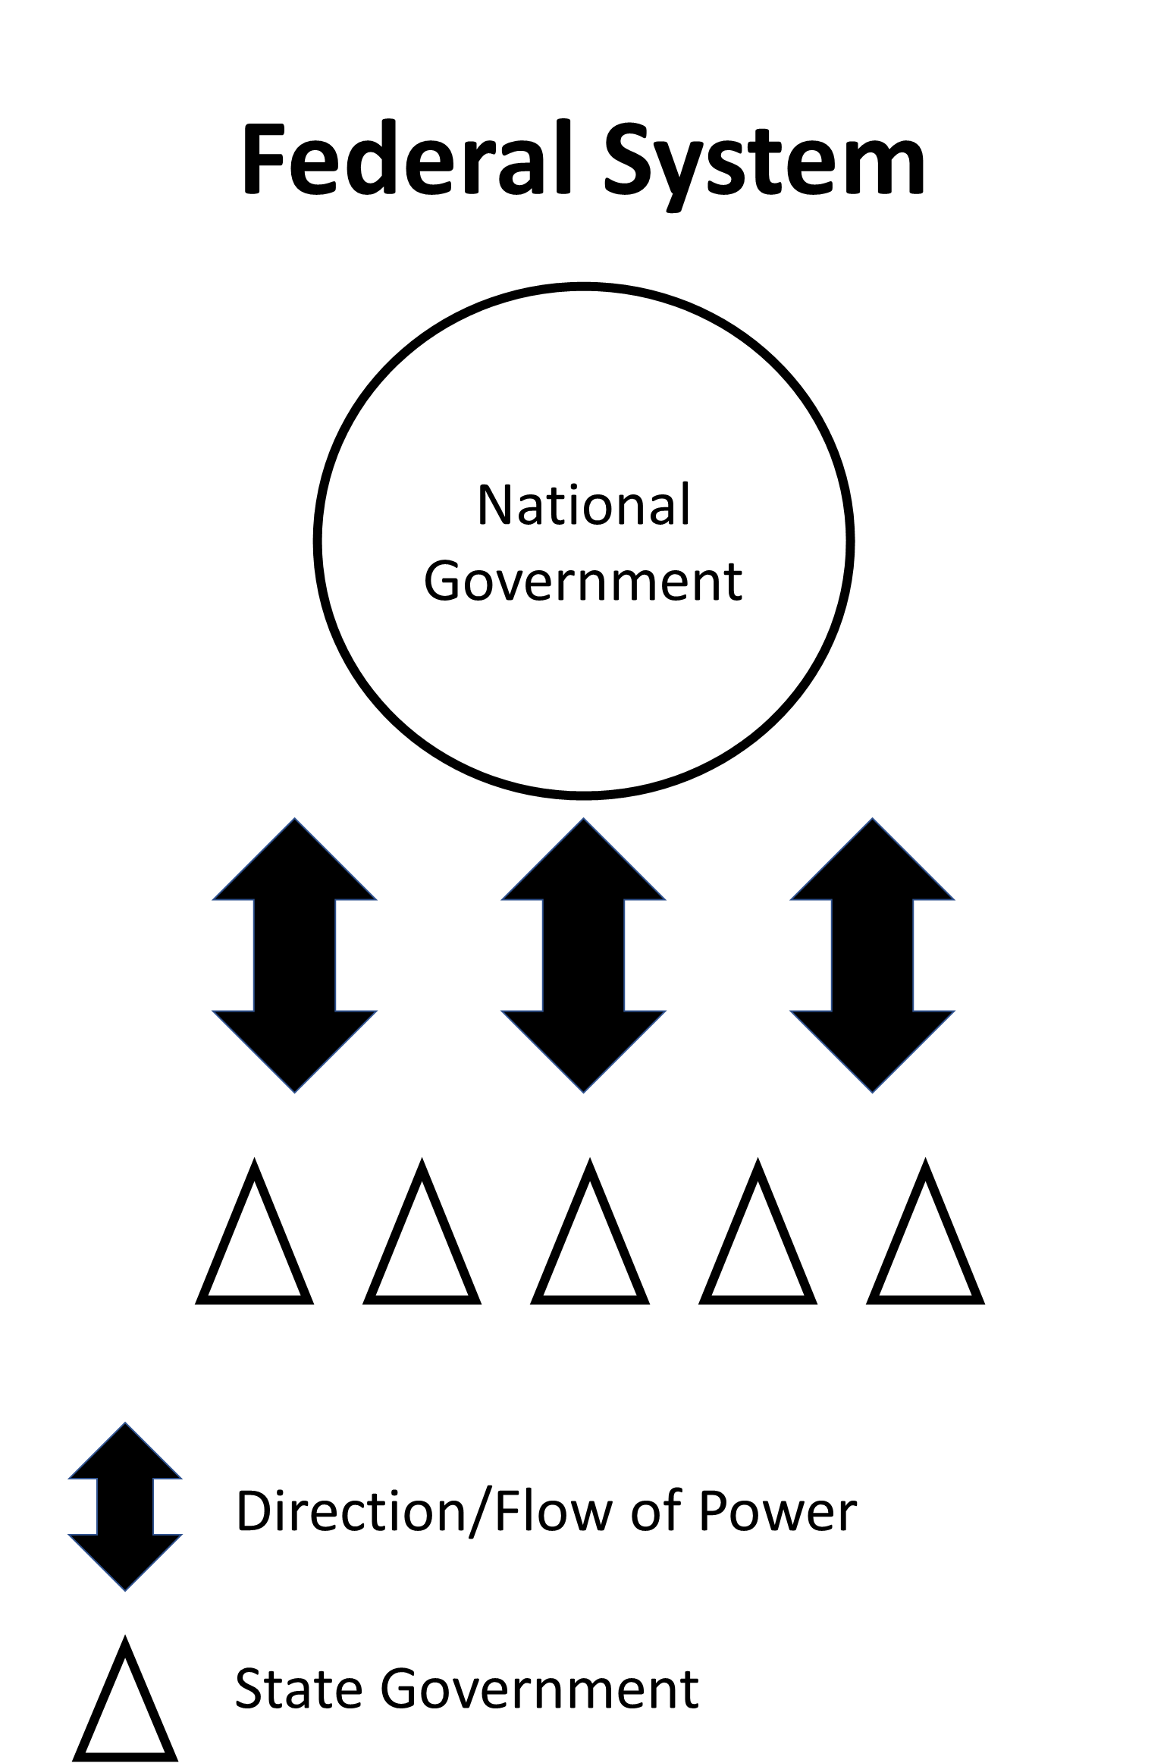
Confederal | Independent states have their own powers. There is no central government. Citizens elect officials of their own state  for the legislative, executive, and judicial branches. | 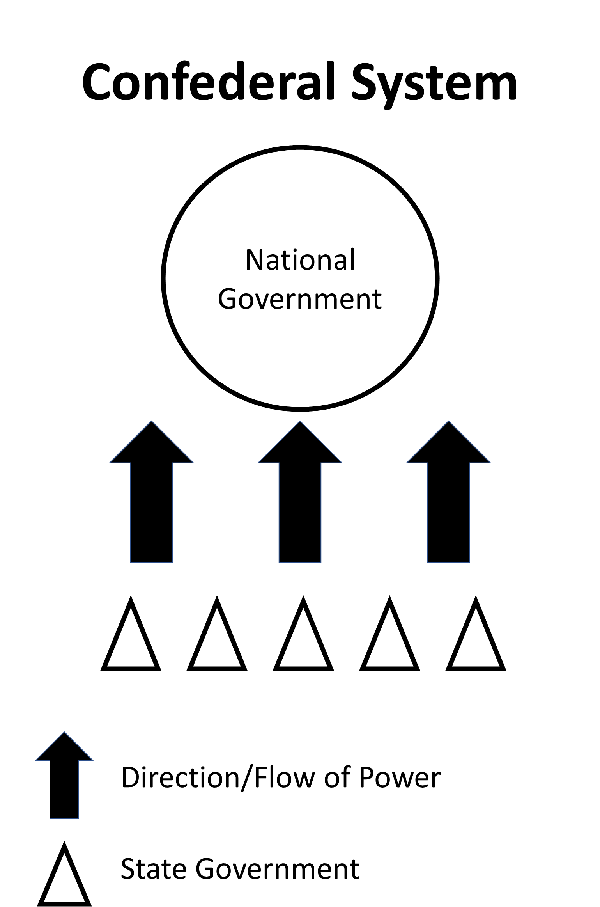
Unitary | The central government has all of the power. The people do not participate in the selection of leaders. The central government makes all decisions for the country. | 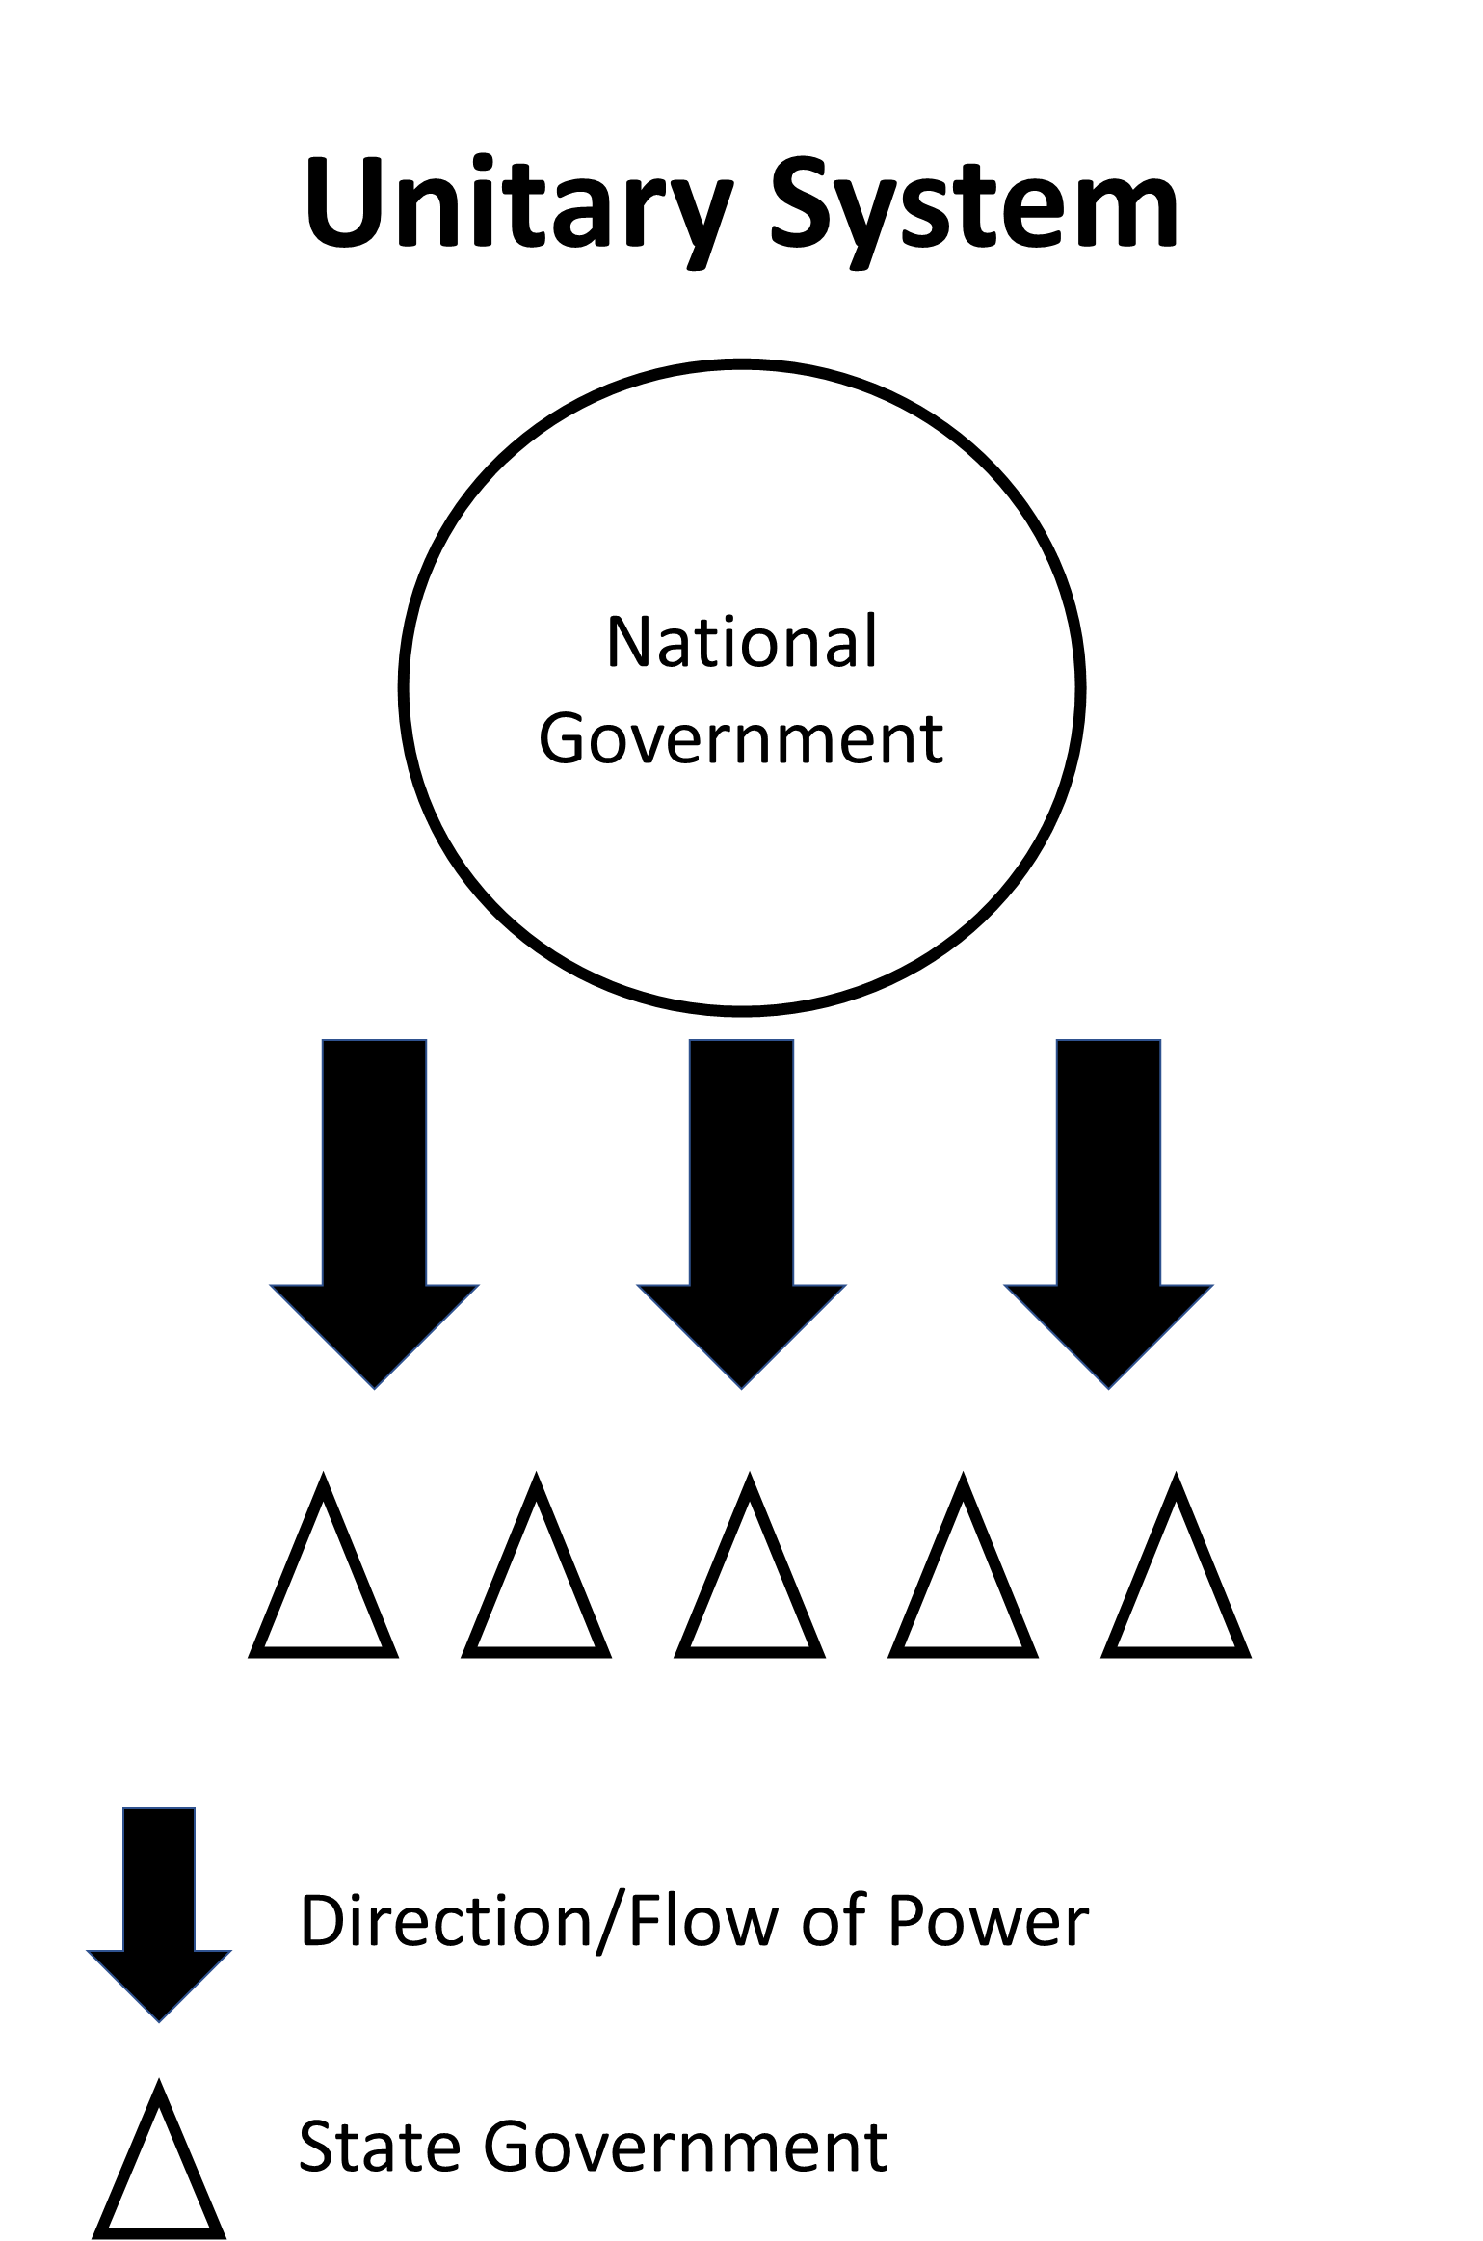

executive - the power of government to enforce laws, make sure laws are followed
judicial - the power of government to interpret laws
legislative - the power of government to make laws

