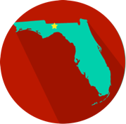 | Federalism  Types of Powers
- I can understand the division of powers between the federal & state governments.
- I can understand enumerated, reserved and concurrent powers.

Enumerated/Delegated Powers
Declare war
Create a military and navy
Forms treaties with other countries
Coin and print money
Establish rules for immigration and naturalization
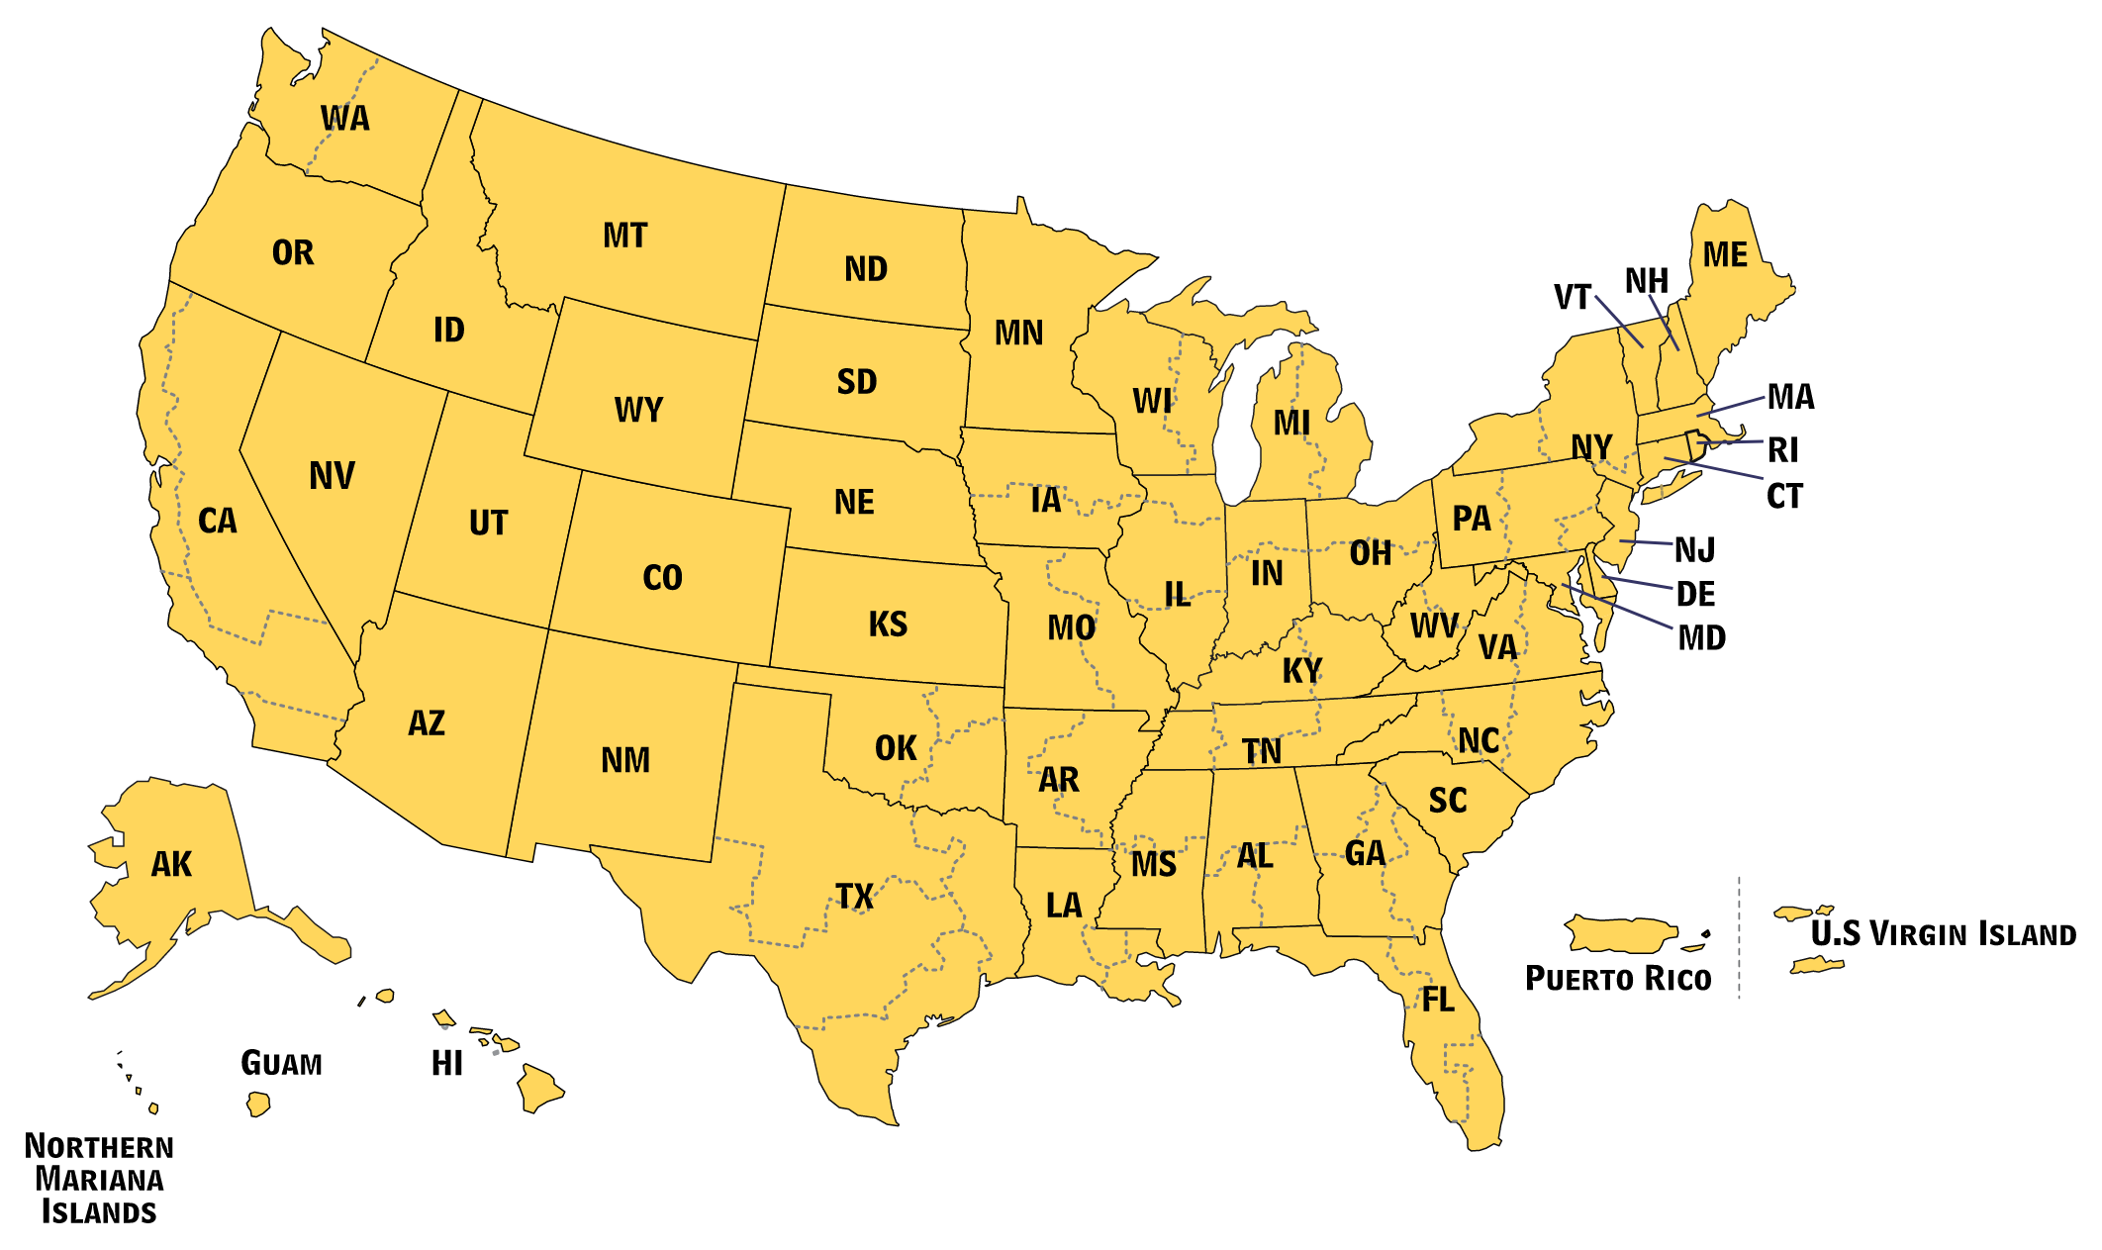
The word “enumerated” means something that is specifically mentioned or listed. The Framers thought it was important to list out the powers of the federal (national) government so that it was clear what it could do. Enumerated, or delegated, powers are powers given to the federal government and they are specifically listed in the Constitution. You can see some of these powers in the table to the right.

The other type of powers included in the Constitution are called reserved powers. The word “reserved” means set aside for a specific person or group. In this case, these powers are specifically reserved, or set aside, for the states by the 10th Amendment of the U.S. Constitution. The 10th Amendment states the following.

“The powers not delegated to the United States by the Constitution, nor prohibited by it to the States, are reserved to the States respectively, or to the people.”

The 10th Amendment does not list any specific powers. Instead, it broadly says that all powers not given to the national government are reserved for the states and the people. This leaves the meaning of reserved powers open to interpretation.
Reserved Powers
Establish and run public schools
Run elections
Establish local governments
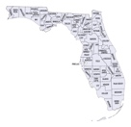

This Amendment protects state powers and prevents the federal government from becoming too powerful. The table to the left shows some reserved powers.
Concurrent Powers
Tax citizens
Borrow money
Establish courts
Create and enforce laws

Finally, we have concurrent powers. The word “concurrent” means at the same time. These are powers that are shared between the states and the federal government. This means these are things they can BOTH do. The table to the right shows some of these powers.

There may be times that Congress uses powers that are not specifically enumerated in the Constitution. For example, one of Congress’ enumerated powers is to raise and support armies. In the past, to increase the number of troops during times of war, Congress passed a law requiring people to join the military, called a draft. The creation of a draft is NOT an enumerated power of Congress, but it does fall under what is called the “necessary and proper clause” of the U.S. Constitution. The “necessary and proper clause” says that

“The Congress shall have power...to make all Laws which shall be necessary and proper for carrying into Execution the foregoing Powers, and all other Powers vested by this Constitution in the Government of the United States...”
Let’s see if we can break down that complicated text from the Constitution into some simpler terms. The “necessary and proper clause” means that Congress might need other powers so it can exercise the powers it has been given. These are called implied powers. The Constitution implies, or suggests but does not specifically state, that the Congress has that ability. We also call this clause the “Elastic Clause”. Like an elastic (or rubber) band, the Congress uses this clause to stretch its powers.

