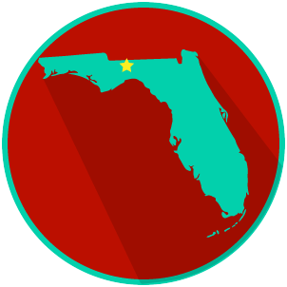
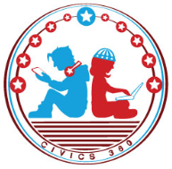
FL State & Local Government: SS.7.CG.3.12
Comparing Constitutions
VIDEO VIEWING GUIDE #2
Name: ______________________________

Date: _______________________________

The Amendment Process Video #2
Question | List Specific Evidence from the Video | Complete Sentence
1. What does it mean to ‘amend’ a constitution?

2. What are the two ways an amendment can be proposed for the U.S. Constitution?

3. What are the two ways an amendment to the U.S. Constitution can be ratified?
4. Based on what you have learned, who is involved in the U.S. Constitution’s amendment process?
5. Who must agree to amend the Florida Constitution?

6. Why do both the U.S. Constitution and the Florida Constitution begin with ‘We the People’?
7. Explain the five different ways an amendment gets on the ballot in Florida.
7a. Constitutional Revision Commission
7b. Taxation and Budget Reform Commission
7c. Constitutional Convention
7d. Ballot Initiative Process
7e. The Florida Legislature
8. How are amendments to Florida’s constitution ratified?

