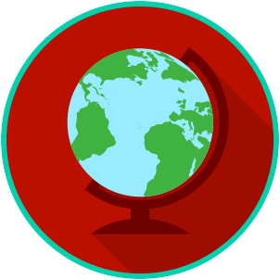
The U.S. & The World: SS.7.CG.3.2
Systems of Government
VIDEO VIEWING GUIDE
Name: ________________________________

Date: _________________________________

Question | List Specific Evidence from the Video | Complete Sentence
1. What are the three powers all forms of government have?

2. What do government systems focus on?
3. In a federal system of government, how is power shared?
4. What do citizens do in many federal systems?
5. What are two examples of a federal system of government?
6. In a confederal system of government, where is the power held?
7. What are two examples of a confederal system?
8. What is a weakness of a confederal system?
9. Who usually holds most of the power in a unitary system of government?
10. What are two examples of a unitary system of government?
11. What is a weakness of a unitary system of government?
12. What advantage does a federal system of government have over other systems?
Scenario | Which system of government is being described?
Scenario 1: There is no central power of government, instead government power is held with at the lower government unit level, such as a state.
Scenario 2: The power of government is shared between the central (national) government and the states.
Scenario 3: Government power is held with the central (national) government.
Practice: Identify the System of Government for each scenario.

