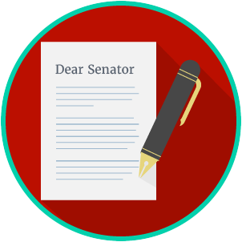
Engaged Citizens: SS.7.C.2.11
Bias, Symbolism and Propaganda
VIDEO VIEWING GUIDE
Name: ________________________________

Date: _________________________________

Question | List Specific Evidence from the Video | Complete Sentence
1. What role does the media play in communicating information between the government, political parties, interest groups, and the public?

2. Define bias.

3. What are some of the ways that the media presents biased information?
4. What is the purpose of political communication from political parties, candidates, and interest groups?
5. Define symbolism.

6. What are some common symbols used in political campaigns?
7. How are symbols used in political communication?
8. Define propaganda.
9. How is propaganda used in political communication?

Practice: For each of the posters below, identify the symbols used and describe how the poster is an example of propaganda.

 | 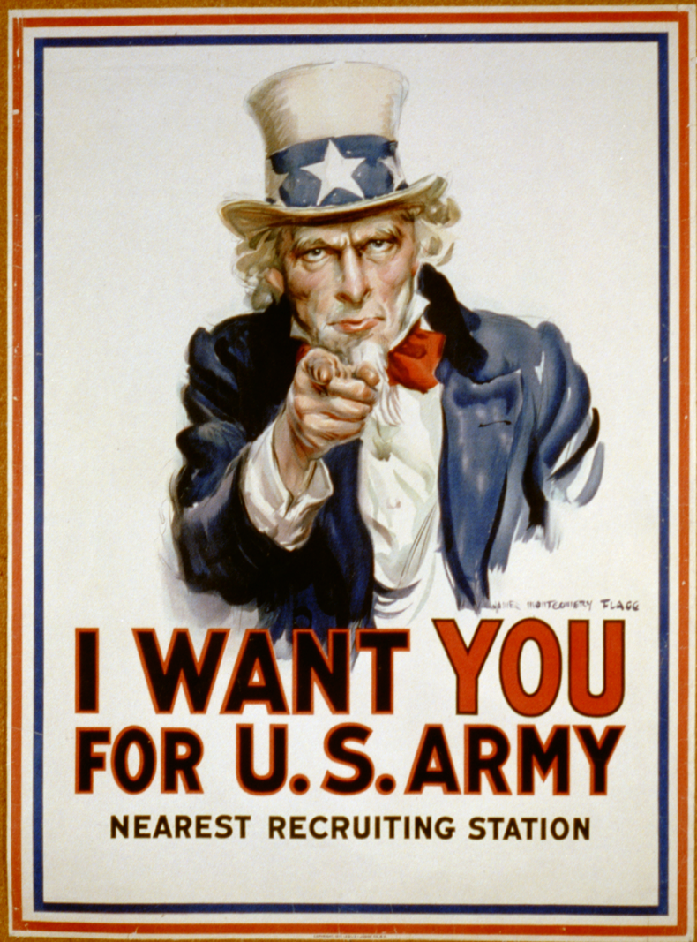
Symbolism: Are the images being used to represent ideas? | Some ideas represented by symbols are: | Some ideas represented by symbols are:
Propaganda: Is the viewer being asked to act a certain way? | This propaganda wants the viewer to: | This propaganda wants the viewer to:

Engaged Citizens: SS.7.C.2.11
Bias, Symbolism and Propaganda
READING GUIDE #1
Name: ________________________

Date: _________________________
Reading: Identifying Bias, Symbolism and Propaganda

Benchmark Clarification 1: Students will use scenarios to identify bias, symbolism, and propaganda.

Reading Task | Response
What ideas are presented in the reading?
What is the central idea of the reading?
Select two words or phrases that support the central idea.
How might this reading connect to your own experience or something you have seen, read, or learned before?
Create a scenario of your own that shows bias, symbolism, or propaganda in media and political communication.

Engaged Citizens: SS.7.C.2.11
Bias, Symbolism and Propaganda
READING GUIDE #2
Name: ________________________

Date: _________________________
Reading: Evaluating Bias, Symbolism and Propaganda

Benchmark Clarification 2: Students will evaluate how bias, symbolism, and propaganda can impact public opinion.

Reading Task | Response
What ideas are presented in the reading?
What is the central idea of the reading?
Select two words or phrases that support the central idea.
How might this reading connect to your own experience or something you have seen, read, or learned before?
How can bias, symbolism, and propaganda impact public opinion? | Bias, symbolism, and propaganda can impact public opinion by:

Engaged Citizens: SS.7.C.2.11
Bias, Symbolism and Propaganda
VOCABULARY PRACTICE
Name: ________________________

Date: _________________________
Bias, Symbolism and Propaganda

Write about your understanding of media and political propaganda by explaining the connections between and among each of the terms in the concept circle.

How do the terms in the concept circle fit together?

Engaged Citizens: SS.7.C.2.11
Bias, Symbolism and Propaganda
PRACTICE QUIZ
Name: ________________________

Date: _________________________
Bias, Symbolism and Propaganda Practice Quiz Reflection

FIRST Attempt Score | I answered ______ questions right.
One thing I learned:

SECOND Attempt Score | I answered ______ questions right.
One thing I learned:

