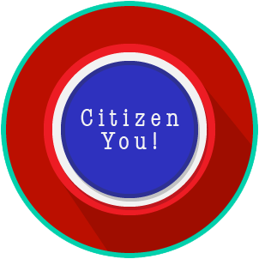
Name: ________________________

Date: _________________________
Citizen You: SS.7.C.2.1
Defining Citizenship
READING GUIDE #3
Reading: The Impact of the Naturalization Process

Benchmark Clarification 3: Students will evaluate the impact of the naturalization process on society, government, or the political process.

Reading Task | Response
What ideas are presented in the reading?
What is the central idea of the reading?
Select two words or phrases that support the central idea.
How might this reading connect to your own experience or something you have seen, read, or learned before?
How does the naturalization process impact society, government, or the political process? | The naturalization process impacts society, government, or the political process through:

