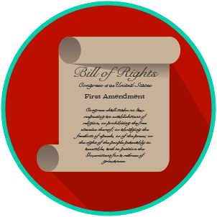
My Rights & Liberties: SS.7.CG.2.3
The Bill of Rights and
Other Amendments
VIDEO VIEWING GUIDE #1
Name: ________________________________

Date: _________________________________

The Bill of Rights and the First Amendment Video #1
Question | List Specific Evidence from the Video | Complete Sentence
1. What is an amendment?

2. Why was a bill of rights added to the U.S. Constitution?

3. What are the first ten amendments to the U.S. Constitution called?
4. What are the five freedoms in the First Amendment?
5. How do the five freedoms protect your liberties?

