Local, State & Federal Lawmakers
- I can compare local, state and federal lawmakers.
The United States has a federal system of government. In this system, the federal (national) and state governments share powers and responsibilities. Lawmaking is a power that is shared at all three levels of government – local, state and federal.

Local Governments
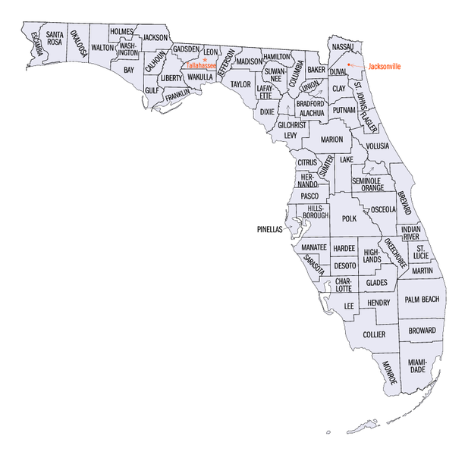
In Florida, the local level of government refers to city and county governments. Local governments in Florida can be organized a few different ways. Depending on how the city or county government is organized, lawmakers could be called city commissioners, city council members, county commissioners, or mayors. These local government officials pass ordinances that govern the people who live in villages, towns, cities, and counties. Ordinances are laws we experience on a daily basis. For example, which school you attend, to how many animals you can own without a permit, to prohibiting littering - these are all decisions made at the local level of government.

State Governments
The Florida state government is organized like the federal government. There is a state house of representatives and a state senate made up of state representatives and state senators. They are called state legislators. State representatives are elected to two-year terms, and state senators are elected to four-year terms. State legislators create state laws (statutes) that impact the people who live in the state. Those laws can range from how many school days are in a year, to state park rules, to robbery and other criminal offenses.

Florida State Legislators (Lawmakers)
Chamber | Description | Official Seal
Florida House of Representatives | - Two-year terms  - Limited to 4 terms  - Districts are based on population  - 120 members | 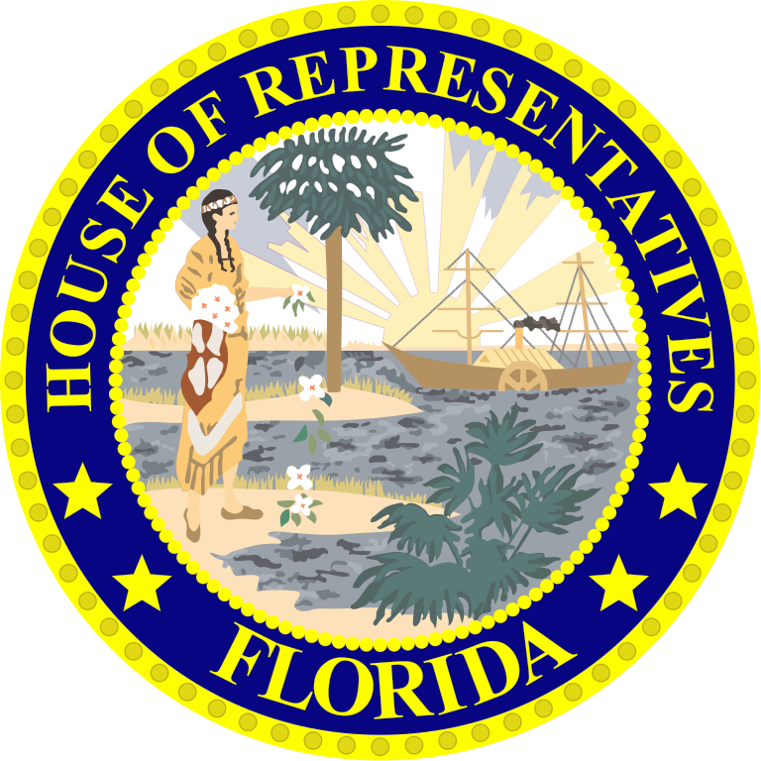
Florida Senate | - Four-year terms  - Limited to 2 terms  - 40 members

Federal Government
At the federal level, each state has a certain number of U.S. Representatives based on the state’s population. U.S. Representatives serve two-year terms and there are no term limits. Each state also has two U.S. Senators. U.S. Senators serve six-year terms and have no term limits. Together U.S. Representatives and U.S. Senators make up Congress. Congress passes federal laws, called acts, which govern everyone in the United States. These laws can range from copyright laws, to issues related to civil rights, counterfeiting money and other federal criminal offenses.

Federal Legislators (Lawmakers)
Chamber | Description | Official Seal
U.S. House of Representatives | - Two-year terms  - No term limits  - Based on each state population  - 435 Total Members | 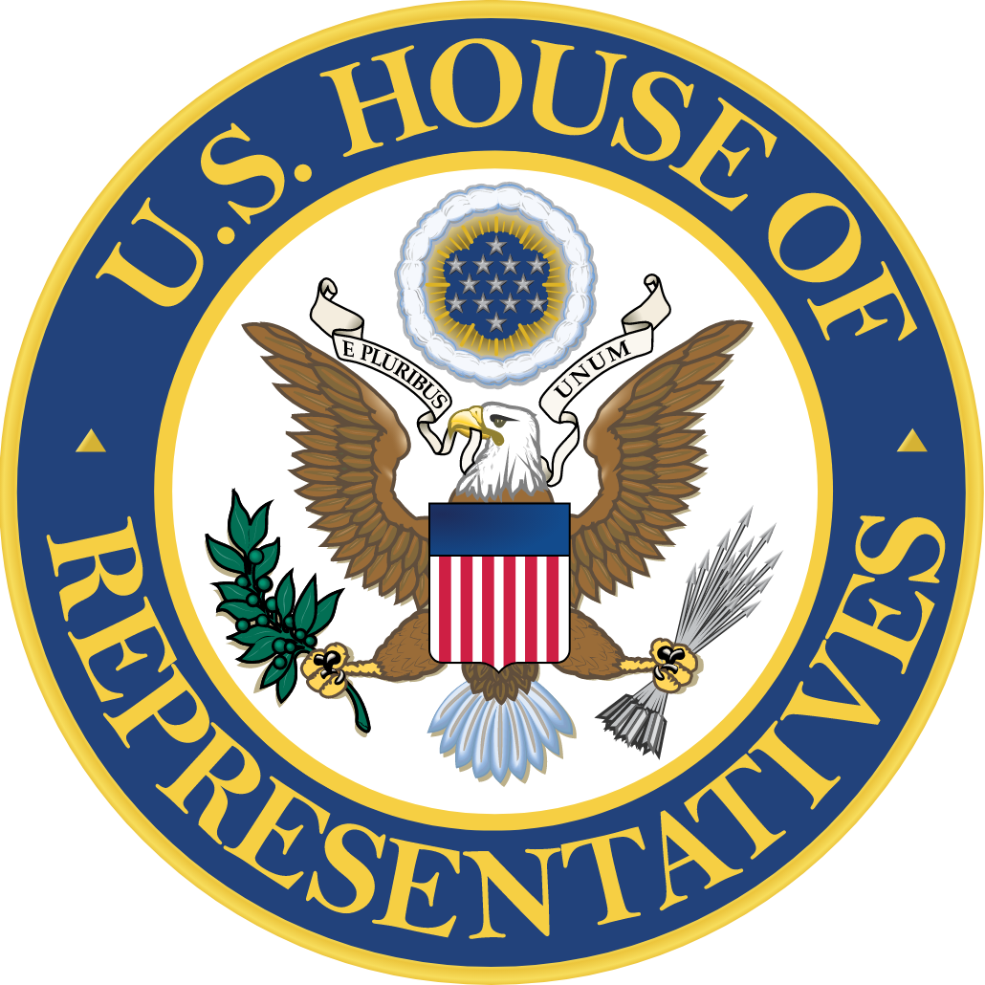
U.S. Senate | - Six-year terms  - No term limits  - Equal representation for each state  - 100 Total Members

