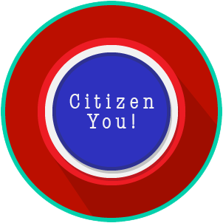
Name: _______________________

Date: ________________________
Citizen You: SS.7.C.2.2, C.2.3 & C.2.14
Citizen Obligations & Responsibilities
VOCABULARY PRACTICE

Citizen Obligations and Responsibilities

Write about your understanding of the obligations and responsibilities of citizens by explaining the connections between and among each of the terms in the concept circle.

How do the terms in the concept circle fit together?

