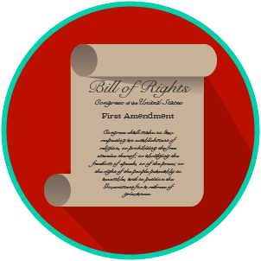
My Rights & Liberties: SS.7.C.3.6
Constitutional Rights and Their Impact
READING GUIDE #4
Name: _______________________

Date: ________________________

Reading: The Impact of Government on Rights

Benchmark Clarification 4: Students will evaluate the impact of the government upholding and/or restricting individual constitutional rights.

Reading Task | Response
What ideas are presented in the reading?
What is the central idea of the reading?
Select two words or phrases that support the central idea.
How might this reading connect to your own experience or something you have seen, read, or learned before?
What must be balanced in order to determine whether to uphold or restrict individual rights? | In order to determine whether to uphold or restrict individual rights, the government must balance:

