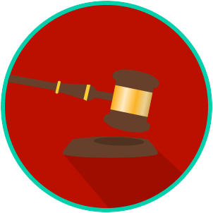
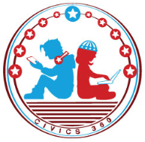
The Legal System: SS.7.C.3.10
Sources & Types of Law
VIDEO VIEWING GUIDE
Name: ________________________________

Date: _________________________________

Question | List Specific Evidence from the Video | Complete Sentence
1. What was the Code of Hammurabi?

2. What did the Code of Hammurabi do?
3. How did the Magna Carta influence the development of laws and government in the United States?
4. How does the Supremacy Clause resolve a conflict between state law and national law?
5. What is constitutional law?

6. What is statutory law?
7. Based on what you have learned, what is the difference between constitutional law and statutory law?
8. What is a precedent?
9. What is civil law?
10. Why do you think we have different laws for juveniles and adults?
11. What is the difference between criminal law and military law?

Name: ________________________

Date: _________________________
The Legal System: SS.7.C.3.10
Sources & Types of Law
READING GUIDE #1
Reading: Historical Law Codes

Benchmark Clarification 1: Students will use examples of historical law codes to identify how laws originated and developed in Western society.

Reading Task | Response
What ideas are presented in the reading?
What is the central idea of the reading?
Select two words or phrases that support the central idea.
How might this reading connect to your own experience or something you have seen, read, or learned before?
How might the Code of Hammurabi and the Magna Carta have influenced the development of our own laws? | The Code of Hammurabi and the Magna Carta have influenced the development of our own laws by:

Name: ________________________

Date: _________________________
The Legal System: SS.7.C.3.10
Sources & Types of Law
READING GUIDE #2
Reading: Sources of Law

Benchmark Clarification 2: Students will recognize constitutional, statutory, case, and common law as sources of law.

Reading Task | Response
What ideas are presented in the reading?
What is the central idea of the reading?
Select two words or phrases that support the central idea.
How might this reading connect to your own experience or something you have seen, read, or learned before?
Explain the difference between constitutional, statutory, case, and common law. | constitutional law
 | statutory law
 | case law
 | common law

Name: ________________________

Date: _________________________
The Legal System: SS.7.C.3.10
Sources & Types of Law
READING GUIDE #3
Reading: Types of Law

Benchmark Clarification 3: Students will compare civil, criminal, constitutional, and/or military law.

Reading Task | Response
What ideas are presented in the reading?
What is the central idea of the reading?
Select two words or phrases that support the central idea.
How might this reading connect to your own experience or something you have seen, read, or learned before?
Which type of law that you read about is most applicable to your life right now and why? | The type of law I read about that is most applicable to my life right  now is ________________ because:

The Legal System: SS.7.C.3.10
Sources & Types of Law
VOCABULARY PRACTICE
Name: ________________________

Date: _________________________
Sources and Types of Law

Write about your understanding of sources and types of law by explaining the connections between and among each of the terms in the concept circle.

How do the terms in the concept circle fit together?

The Legal System: SS.7.C.3.10
Sources & Types of Law
PRACTICE QUIZ
Name: ________________________

Date: _________________________
Sources and Types of Law Practice Quiz Reflection

FIRST Attempt Score | I answered ______ questions right.
One thing I learned:

SECOND Attempt Score | I answered ______ questions right.
One thing I learned:

