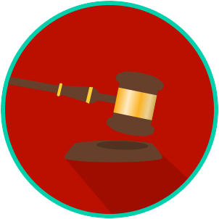
Name: ________________________

Date: _________________________
The Legal System: SS.7.C.3.10
Sources & Types of Law
READING GUIDE #2
Reading: Sources of Law

Benchmark Clarification 2: Students will recognize constitutional, statutory, case, and common law as sources of law.

Reading Task | Response
What ideas are presented in the reading?
What is the central idea of the reading?
Select two words or phrases that support the central idea.
How might this reading connect to your own experience or something you have seen, read, or learned before?
Explain the difference between constitutional, statutory, case, and common law. | constitutional law
 | statutory law
 | case law
 | common law

