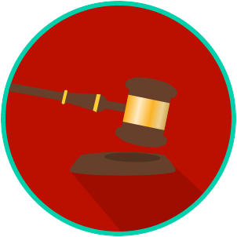
Name: ________________________

Date: _________________________
The Legal System: SS.7.C.3.10
Sources & Types of Law
READING GUIDE #3
Reading: Types of Law

Benchmark Clarification 3: Students will compare civil, criminal, constitutional, and/or military law.

Reading Task | Response
What ideas are presented in the reading?
What is the central idea of the reading?
Select two words or phrases that support the central idea.
How might this reading connect to your own experience or something you have seen, read, or learned before?
Which type of law that you read about is most applicable to your life right now and why? | The type of law I read about that is most applicable to my life right  now is ________________ because:

