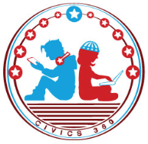
The Founding: SS.7.CG.1.5
The Road to Independence
VIDEO VIEWING GUIDE #3
Name: ________________________________

Date: _________________________________
The Declaratory Act and the Quartering Act #3
Question | List Specific Evidence from the Video | Complete Sentence
1. What was the Declaratory Act?
2. How did the colonists respond to the Declaratory Act?

3. What was the Quartering Act?
4. How did the colonists feel about the Quartering Act?
5. How would the Quartering Act later impact the writing of the US Constitution’s Bill of Rights?

