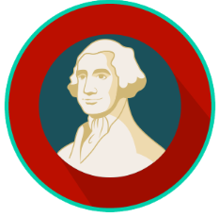
The Founding: SS.7.CG.1.2
Founding Principles
VIDEO VIEWING GUIDE #1
Name: ________________________________

Date: _________________________________

Question | List Specific Evidence from the Video | Complete Sentence
1. What three rights did John Locke, and the Founders, say belonged to all people?
2. What are two things that the Declaration of Independence said that the government is expected to protect and ensure?

3. Where in the Declaration of Independence do we find the importance of natural rights?
4. Explain the concept of natural rights.
5. What is the idea of the social contract?
6. What is the purpose of limited government?
7. What are two ways that the Constitution ensures limited government?
8. What are two ways that the Declaration of Independence talks about the importance of limited government?
9. What is the idea of the rule of law?
10. Can presidents or other political leaders break the law while they are in office? Why or why not?
11. Describe the principle of due process of law.
12. Where in the Constitution do we find due process of law?
13. What is the connection between habeas corpus and due process?
14. Explain the concept of religious liberty.
15. Where do we find protection for religious liberty in the Constitution?
16. In plain words, what 3 things does the Virginia Statute for Religious Freedom say?

Extra Notes Section

