Article II
The Executive Branch

- I can recognize the structure of the executive branch.
- I can identify the powers described in Article II in the U.S. Constitution.

The U.S. Constitution is a document that outlines the structure and function of the United States government. The Framers’ of the U.S. Constitution believed they needed to create a new government system to fix problems in the Articles of Confederation. They also wanted to protect citizens’ individual rights. These beliefs led to the creation of Articles I, II and III of the U.S. Constitution. These articles create the three branches of government. Each article covers one branch.

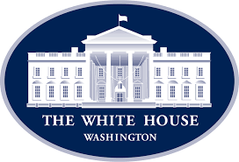
Article II creates the executive branch of government and defines its primary job to enforce and carry out laws. Article II creates the role of the president who is the head of this branch and is responsible for the enforcement of the laws created by Congress.

Article II also creates what is known as departments. These departments assist and advise the president. They are in charge of implementing laws passed by Congress and executive orders of the president. Heads of the 15 major departments are members of the Cabinet. Members of the Cabinet are the president’s advisers.

The President and Agencies
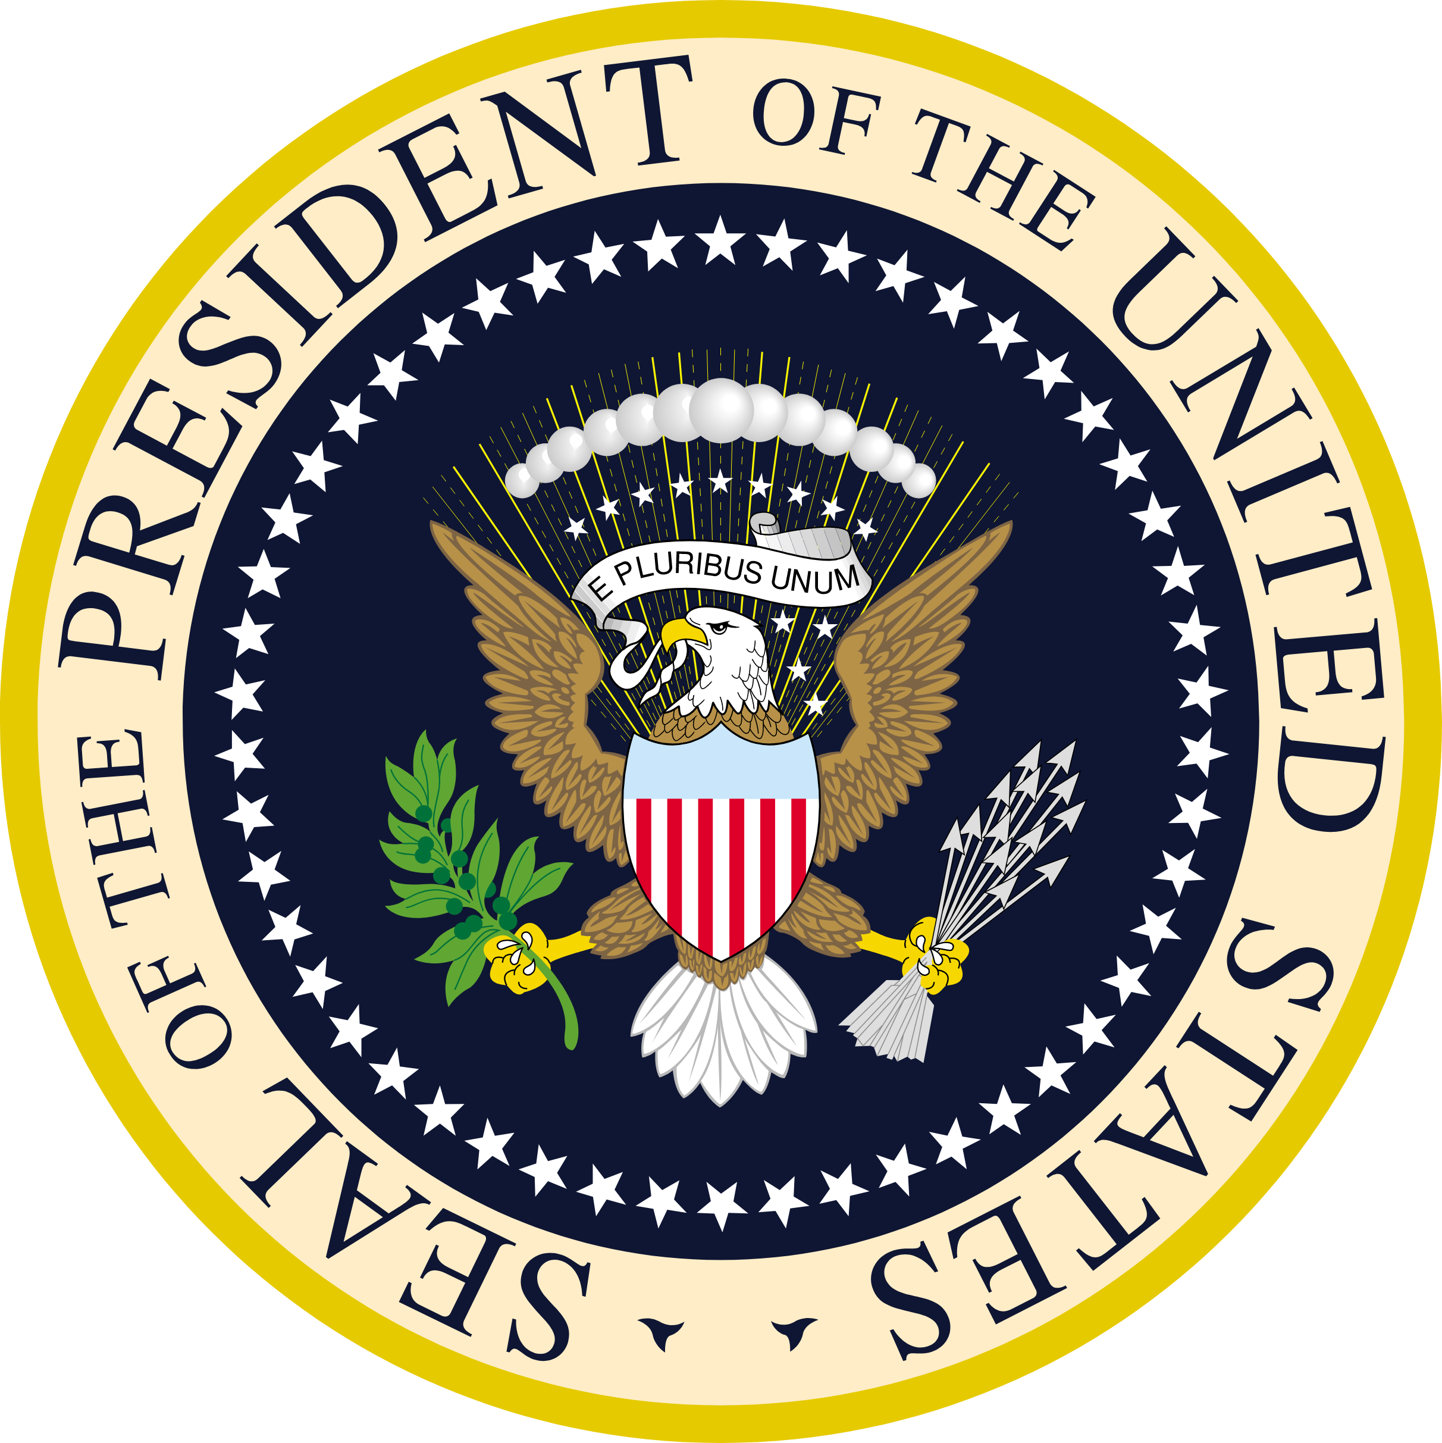
- The executive branch handles the day-to-day tasks required to run a country through the use of departments.
- Article II defines the various roles of the president, such as, Commander-in-Chief, Chief Diplomat, Head of State, and MORE!
- Article II describes the qualifications needed to be the president, defines the powers of the office of president, and what happens if the president behaves in a manner not consistent with the office.
- Lastly, Article II describes the term limits of the office of the president and the Electoral College. The Electoral College is a group of people representing each state. These people formally cast votes for the election of the president and vice president.

THE POWER OF THE PRESIDENT
These are powers granted to the president by Article II:
power to enforce laws
serve as the Commander-in-Chief of the armed forces
power to veto bills
grant pardons and reprieves (postpone punishments) to people convicted of federal crimes
power to make treaties with leaders of other nations
power to nominate people to serve in the Cabinet, the Supreme Court, and other high government positions

