Responsibilities and Obligations of Citizens
Reading Two
- I can distinguish between citizen obligations and duties.

The United States defines the term citizen in the Fourteenth (14th) Amendment of the Constitution as someone who is born or naturalized in the United States. Being a U.S. citizen means that there are both obligations and responsibilities that must be met to support our representative democracy and to make sure citizens’ rights are protected.

Obligations, also known as duties, are things that we HAVE to do or we could face legal consequences, such as fines or jail time. Responsibilities are things we SHOULD do so that our communities are nice places to live. Obligations and responsibilities contribute to the common good. The common good is actions or beliefs that benefit everyone in a community.

Obligations of Citizens | Responsibilities of Citizens
- Obeying Laws (Federal, State & Local)  - Paying Taxes  - Defending the nation (Selective Service)  - Jury Duty  - Attending School | - Voting  - Attending civic meetings  - Petitioning the government  - Running for office  - Volunteering

How do citizen obligations and responsibilities impact the common good? Let’s look more closely at each obligation and responsibility and how that action promotes the betterment of the community, whether that is the United States, an individual state, or your local city.

CITIZEN OBLIGATIONS
Obligation |  | How does this obligation relate to the common good?
Obey Laws | 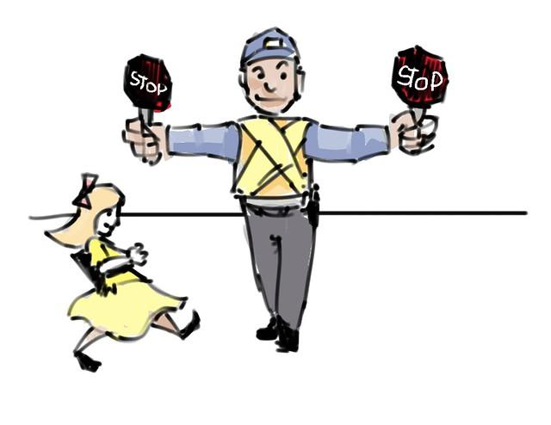 | There are federal, state and local laws that everyone has to follow. By following the law and not committing crimes, communities are less dangerous places.
Pay Taxes |  | Taxes pay for large programs that benefit everyone (road, schools, libraries, and more). There are federal, state, and local taxes that everyone must pay. By paying taxes, citizens help make sure that the government can afford to provide services that benefit the general public.
Jury Duty | 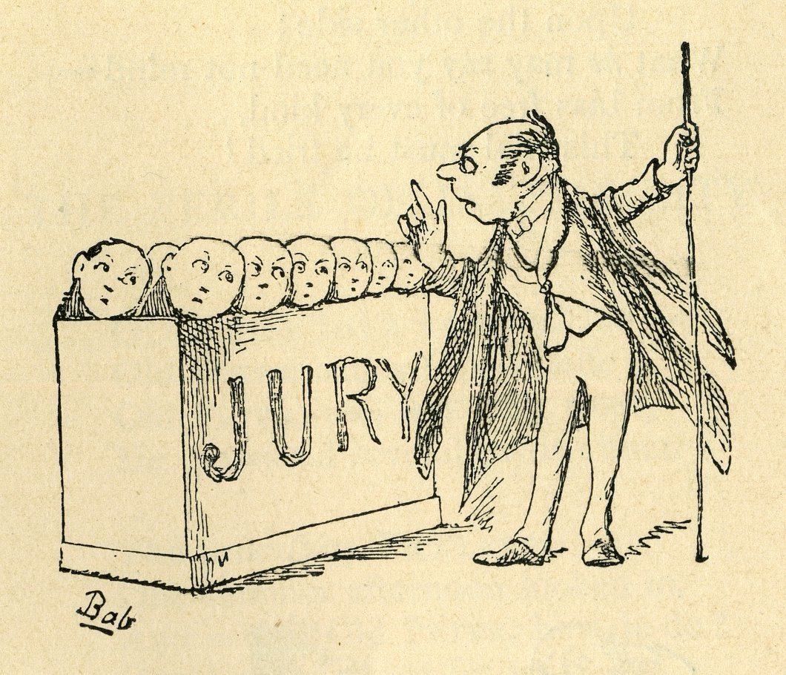 | By serving on juries, citizens make sure that the right to a trial by jury is protected.
Defend the Nation |  | All males between the ages of 18-25 have to register for Selective Service. By defending the nation, if asked to do so, citizens make sure that those who live in the United States are protected from enemies who may hurt us.
Attend School |  | All citizens must attend school until they are at least 16.  By attending school, students learn the skills and knowledge needed to be responsible citizens.

CITIZEN RESPONSIBILITIES
Responsibility |  | How does this responsibility relate to the common good?
Voting |  | Voting in elections is one way for citizens to be heard by the leaders who represent them. Voting contributes to the common good because as more citizens vote, more decisions represent the views of the people.
Attending Civic Meetings |  | By attending civic meetings, a citizen can be more informed about issues or public policy and they can voice their opinions and be heard by public officials.
Petitioning the Government |  | Petitioning the government is a right listed in the First (1st) Amendment to the U.S. Constitution. This right allows people to express their concerns to the government and ask the government to address issues. A petition may formally ask the government to make changes in the law. It also may include signatures of those who support the changes.
Running for Office | 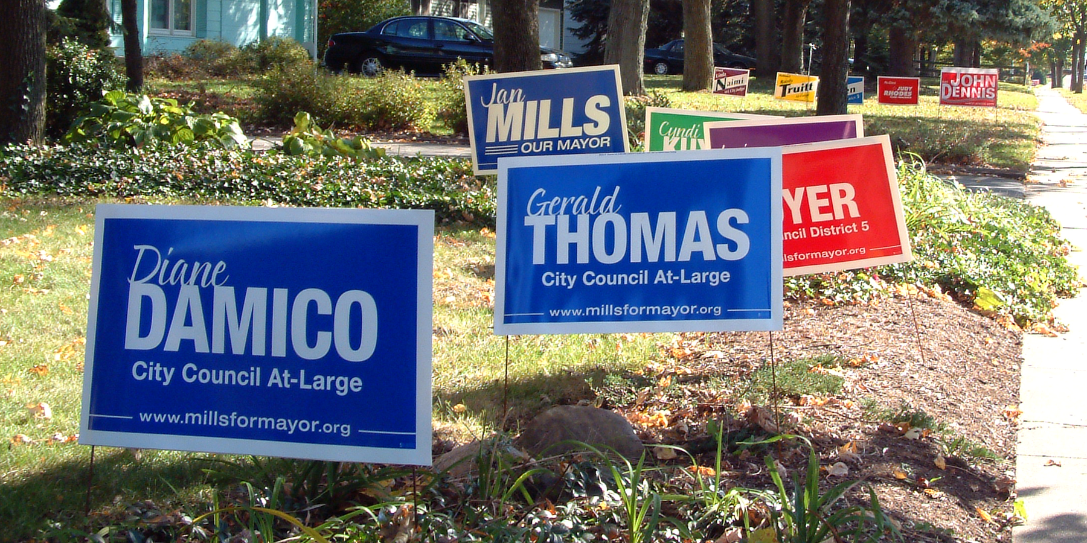 | Running for elected office provides citizens an opportunity to become involved in the government and represent their community.
Volunteering |  | Community service, or volunteering, helps the common good. It benefits everyone when a citizen sees a need in his or her community and takes that extra step to find a solution.

