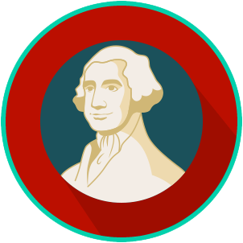
Founders’ Influences: SS.7.CG.1.1
Ancient and Religious Influences
READING GUIDE #1
Name: ________________________

Date: _________________________

Reading: Influence of Ancient Greece

Benchmark Clarification 1: Students will explain the influence of ancient Greece on America’s constitutional republic (e.g., civic participation, legislative bodies, polis, voting rights, written constitution).

Reading Task | Response
What ideas are presented in the reading?
What is the central idea of the reading?
Select two words or phrases that support the central idea.
How might this reading connect to your own experience or something you have seen, read, or learned before?
Explain at least two influences of ancient Greece on America’s constitutional republic? | Influences of ancient Greece on America’s constitutional republic include:

