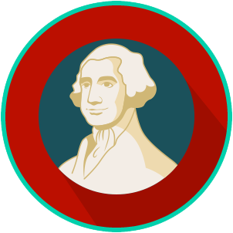
Founders’ Influences: SS.7.CG.1.1
Ancient and Religious Influences
READING GUIDE #2

Name: ________________________

Date: _________________________

Reading: Influence of Ancient Rome

Benchmark Clarification 2: Students will explain the influence of ancient Rome on America’s constitutional republic (e.g., civic participation, republicanism, representative government, rule of law, separation of powers).

Reading Task | Response
What ideas are presented in the reading?
What is the central idea of the reading?
Select two words or phrases that support the central idea.
How might this reading connect to your own experience or something you have seen, read, or learned before?
Explain at least two influences of ancient Greece on America’s constitutional republic? | Influences of ancient Rome on America’s constitutional republic include:

