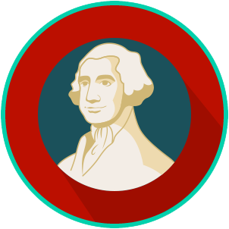
Founders’ Influences: SS.7.CG.1.1
Ancient and Religious Influences
READING GUIDE #4
Name: ________________________

Date: _________________________

Reading: Judeo-Christian Ethical Ideas

Benchmark Clarification 4: Students will explain how the Judeo-Christian ethical ideas of justice, individual worth, personal responsibility, and the rule of law influenced America’s constitutional republic.

Reading Task | Response
What ideas are presented in the reading?
What is the central idea of the reading?
Select two words or phrases that support the central idea.
How might this reading connect to your own experience or something you have seen, read, or learned before?
Explain where Judeo-Christian ethical ideas of justice, individual worth, personal responsibility and the rule of law are present in America’s constitutional republic today. | Justice:
 | Individual worth:
 | Personal responsibility:
 | Rule of law:

