Citizenship

- I can define the term citizen.
- I can explain the legal ways to become a citizen.

The U.S. Constitution is the supreme law of the United States. It was ratified, or approved, in 1789. At the time, it did not have a clear definition of U.S. citizenship. But, the Constitution did mention citizenship several times. A formal definition of U.S. citizenship was added to the Constitution when the 14th Amendment was ratified in 1868. This was over 80 years after the U.S. Constitution was written! According to the 14th Amendment, a citizen is defined simply as:

“All persons born or naturalized in the United States.”
Passports are a form of legal identification used for travel. Only legal citizens of a country can have a passport.

This means that the 14th Amendment defines citizenship as belonging to anyone who is born in the United States, or anyone who is an immigrant and has gone through the naturalization process.

First, let’s look at birth citizenship. There are two ways: law of blood and law of soil.

Law of Blood |  | One way to become a citizen by birth is for one of the person’s birth parents to be a U.S. citizen. In most cases, this means that U.S. citizenship is passed to the child from the natural mother or father. This method of gaining citizenship is called the law of blood.
Law of Soil |  | The second way to become a citizen by birth is if a person is born in the United States, some of its territories, or on a U.S. military base, that person is a citizen through what is called the “law of soil”. This method of becoming a citizen does not require the person’s mother or father to be a U.S. citizen.

In the United States there are also people who are considered aliens. Aliens are persons living in the U.S. who are not citizens. Aliens can be in the U.S. for temporary purposes. This could be for a job or to visit for a certain period of time. Or, aliens can be in the United States as a legal permanent resident. This is someone who is permanently living in the U.S. legally but not a citizen. When someone moves permanently to live in a new country they are also called immigrants. Many of the immigrants who come to the United States to begin a new life go through the process to gain citizenship. This process is called naturalization.

Naturalization Process
The process of naturalization is also mentioned in the 14th Amendment. Let’s look at the qualifications required for that process.
To apply for citizenship, an immigrant must:

 | Be at least 18 years old.
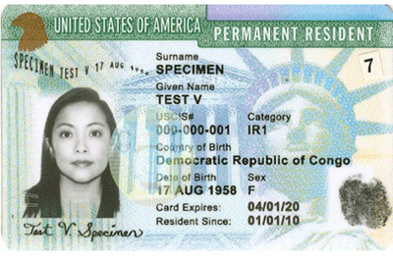 | Have been a resident (someone who lives in a place for a minimum period of time) of the United States for five years  - Residents cannot have left the country for more than 30 months combined.  - Residents must have lived in the U.S. for at least 12 months uninterrupted in the 5 years.
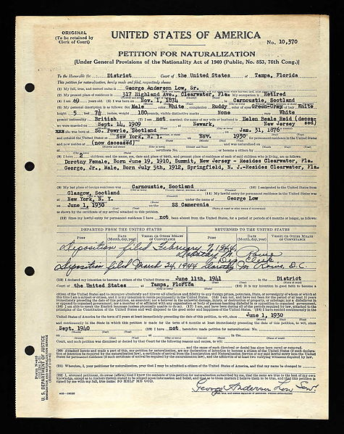 | File a petition for naturalization; this is similar to filling out an application stating that a person wants to become a citizen
https://www.af.mil/News/Article-Display/Article/124169/tuition-assistance-allows-airmen-to-reach-educational-goals/ | Take a test that shows they can read, write and speak English well enough to demonstrate that they know United States history and the U.S. Constitution.
Be able to prove that they are of good moral character which means they can prove they are not a criminal.
- Must have two U.S. citizens confirm that the applicant is of good moral character.
https://www.aviano.af.mil/Articles/Photos/igphoto/2000346226/ | Once all of the conditions have been met, the applicant takes the “Oath of Allegiance”. This means that people wanting to become a citizen must pledge their loyalty to the United States.

