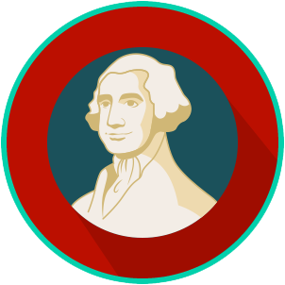
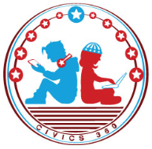
The Founding: SS.7.CG.1.1
Influence of Ancient Greece
VIDEO VIEWING GUIDE
Name: ________________________________

Date: _________________________________
Influence of Ancient Greece
Question | List Specific Evidence from the Video | Complete Sentence
1. What civilization is known as the birthplace of democracy?

2. Who holds the political power in a democracy?

3. Where does the word ‘democracy’ come from?
4. What is a polis?
5. What word or words are related to the word ‘polis’?
6. What city-state was most influential on the ideas of the Founding Fathers?
7. How does an oligarchy differ from a democracy?
8. What is the key difference between a direct democracy and a representative democracy?
9. Where will we find a description of the structure, powers, and duties of a government in most democracies?
10. What part of government made the laws for Athens?
11. Give an example of civic participation in Athens.
12. Who was considered a citizen in Athens?
13. Why wouldn’t someone want to win an election that was focused on ostracism?
14. Why was Athens able to have a direct democracy but the United States is not?

