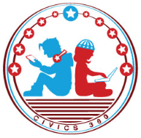
The U.S. & The World: SS.7.CG.3.1
Forms of Government
VIDEO VIEWING GUIDE #3
Name: ________________________________

Date: _________________________________
Forms of Government Video #3
Question | List Specific Evidence from the Video | Complete Sentence
1. What is meant by the phrase ‘form of government’?
2. Explain the three basic powers of all governments. | legislative power
 | executive power
 | judicial power
4. What type of government does the United States have?
5. What distinguishes our constitutional republic from other forms of government?
6. Where can we find our Founding Principles?

Describe: For each of the principles below, describe how it protects our rights and liberties
Founding Principles | Description
Separation of Powers and Checks and Balances
Republicanism, Democracy, Representative Government, Consent of the Governed
Limited Government, Due Process of Law, Individual Rights, Rule of Law
Federalism

Question | List Specific Evidence from the Video | Complete Sentence
7. What are the principles that protect our freedoms and liberties?

