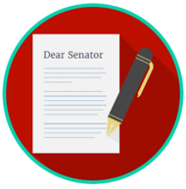
Engaged Citizens: SS.7.CG.2.9
Bias, Symbolism, and Propaganda
READING #2
Name: ________________________

Date: _________________________

SS.7.CG.2.9 Benchmark Clarification 2: Students will evaluate how bias, symbolism and propaganda can impact public opinion.

Bias, symbolism, and propaganda can influence public opinion (how citizens think about candidates or issues). The media plays a major role in influencing public opinion.
Sometimes the information that the media gives the public is biased. Bias means that one side is favored over another in how information is presented. Media bias can happen when the media decides what to report and how much information to share with the public; this is a problem for the public because they are only getting the side of the story that the news media wants them to hear.
Symbolism is the use of symbols to send a message. The media may use symbolism as a sort of “shortcut” to convey their message to a certain group; this can be a problem because many symbols may have a negative meaning to some people.
Propaganda is similar to bias and symbolism in that they are all used to persuade; however, propaganda uses more extreme measures to communicate a certain message. Propaganda relies on appealing to the viewer’s emotion rather than reason to communicate or believe something in a certain way. Propaganda can include symbols, a poster, or a TV commercial.
Here are some famous examples of propaganda:

Example #1: Uncle Sam
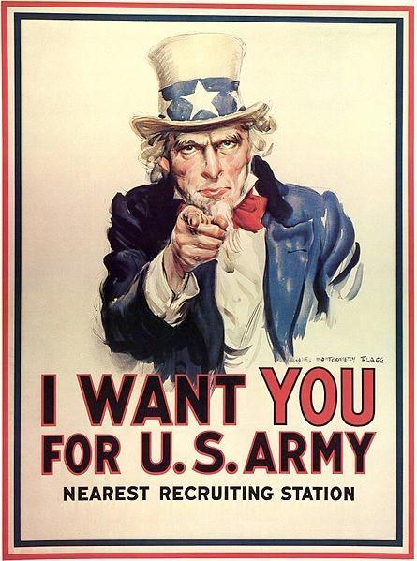

This poster is one of the most famous propaganda pieces in American history. It was originally supposed to be a magazine cover during World War I to encourage American citizens to be prepared for war. Because this poster was so popular, President Franklin Roosevelt decided to use this propaganda poster to encourage young men to join the U.S. Army in World War II. The patriotic colors and the slogan “We Want You!” are great examples of how the government used symbolism and propaganda to get the American public to feel a certain way. It played a role in getting hundreds of thousands of men to decide it was their patriotic duty to join the Army during World War II

Example #2: Rosie the Riveter
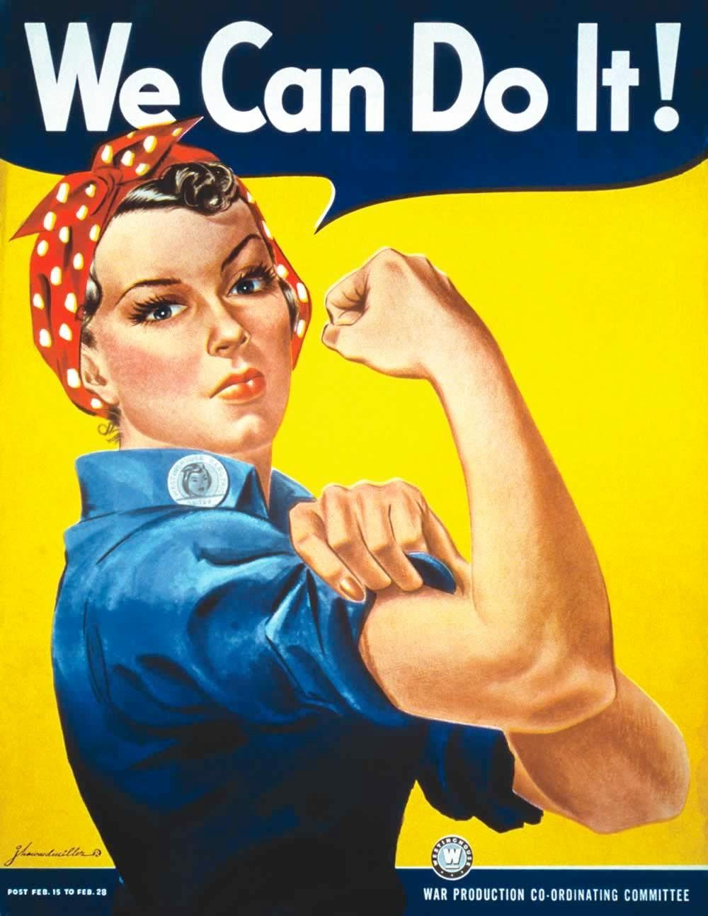

During World War II, women in the United States took jobs they had never had before. Hundreds of thousands of American men had joined the military, and women were needed to replace them in many different types of jobs. “Rosie the Riveter,” pictured here, was the face of the propaganda campaign that encouraged women to do their patriotic duty and take jobs in the munitions industry (making guns, ammunition, and other weapons). “Rosie” became a famous symbol of how American women supported the country during World War II.
bias - a preference, opinion or attitude that favors one way of thinking or feeling over another
media - plural form of the word “medium,” refers to various means of communication. For example, television, radio, newspapers and the Internet (web) are different types of media. The term can also be used to describe news organizations as a whole group.
propaganda - the method of spreading ideas or information for the purpose of helping or hurting an institution, a cause, or a person
symbolism - the use of something to represent ideas or qualities

