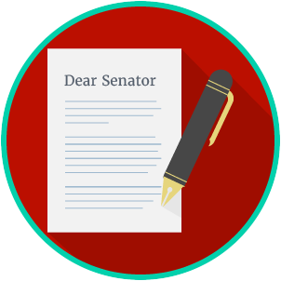
Engaged Citizens: SS.7.C.2.11
Bias, Symbolism and Propaganda
READING GUIDE #1
Name: ________________________

Date: _________________________
Reading: Identifying Bias, Symbolism and Propaganda

Benchmark Clarification 1: Students will use scenarios to identify bias, symbolism, and propaganda.

Reading Task | Response
What ideas are presented in the reading?
What is the central idea of the reading?
Select two words or phrases that support the central idea.
How might this reading connect to your own experience or something you have seen, read, or learned before?
Create a scenario of your own that shows bias, symbolism, or propaganda in media and political communication.

