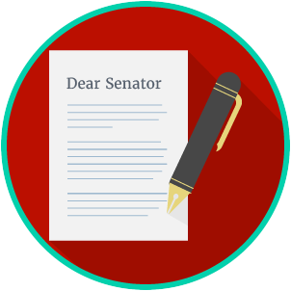
Engaged Citizens: SS.7.C.2.11
Bias, Symbolism and Propaganda
READING GUIDE #2
Name: ________________________

Date: _________________________
Reading: Evaluating Bias, Symbolism and Propaganda

Benchmark Clarification 2: Students will evaluate how bias, symbolism, and propaganda can impact public opinion.

Reading Task | Response
What ideas are presented in the reading?
What is the central idea of the reading?
Select two words or phrases that support the central idea.
How might this reading connect to your own experience or something you have seen, read, or learned before?
How can bias, symbolism, and propaganda impact public opinion? | Bias, symbolism, and propaganda can impact public opinion by:

