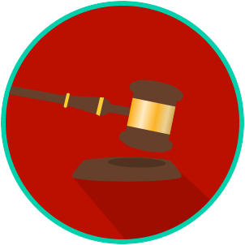
Name: ________________________

Date: _________________________
The Legal System: SS.7.C.3.12
Landmark Supreme Court Civil Liberties Cases
READING GUIDE #2

Reading: Supreme Court Cases and Their Impact - Civil Liberties

Benchmark Clarification 2: Students will evaluate how these U.S. Supreme Court cases have had an impact on society.

Reading Task | Response
What ideas are presented in the reading? (use other side if necessary)
What is the central idea of the reading?
Select two words or phrases that support the central idea.
How might this reading connect to your own experience or something you have seen, read, or learned before?
Describe how two of the cases you have read about have impacted society. (use other side if necessary) | The two cases I chose are ________________________________  and ____________________________. Each one impacted society  by:

