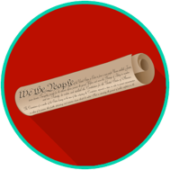
Constitutional Principles and Structures: SS.7.CG.1.8
U.S. Constitution Preamble
READING #3
Name: ________________________

Date: _________________________

SS.7.CG.1.8 Benchmark Clarification 3: Students will recognize that the intention of the phrase “We the People” means that government depends on the people for its power and exists to serve them.

The Preamble begins with the phrase, “We the People.” The writers of the U.S. Constitution began the Preamble with these words to make it clear that the people would be the source of the government’s power and that power would not fall into the hands of a single ruler. Also, by starting the Preamble in this way, the writers were saying that the government exists to serve the people and must answer to them.
Article VII (7) of the Constitution requires that the Constitution could only be ratified by a two-thirds (2/3) majority of the conventions of the states (established by the state legislatures, which were elected by the people). In this way, too, the national government looked to the people for its power.

Preamble - the introduction to the U.S. Constitution
ratify - to confirm by expressing consent; formally approve

