FL State & Local Government: SS.7.C.3.14
State and Local Government Obligations and Services
VOCABULARY PRACTICE
Name: ______________________

Date: _______________________
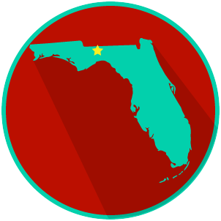

State and Local Government Obligations and Services

Write about your understanding of state and local government obligations and services by explaining the connections between and among each of the terms in the concept circle.

How do the terms in the concept circle fit together?

