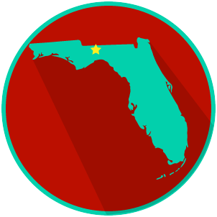
FL State & Local Government: SS.7.CG.3.13
State and Local Government
Obligations and Services
VIDEO VIEWING GUIDE
Name: ______________________________

Date: _______________________________

Question | List Specific Evidence from the Video | Complete Sentence
1. What kind of power is listed in Article I, Section 8 of the Constitution?

2. What is meant by ‘enumerated powers’?

3. What kind of power is mentioned in the Tenth Amendment to the U.S. Constitution?
4. What is meant by ‘reserved powers’?
5. What are examples of reserved powers?

6. What are concurrent powers?
7. What are examples of concurrent powers?
8. What kinds of services do state tax dollars provide?
9. Scenario: You have just moved from Casper, Wyoming to Tallahassee, Florida and you need a driver’s license.

Do you contact the federal, state, or local government and why?
10. Why do local governments provide more services to the people than state or federal government?
11. What kinds of services do local governments provide?
12. Scenario: You go to brush your teeth and realize there is not any water.
Which level of government would you contact and why?

