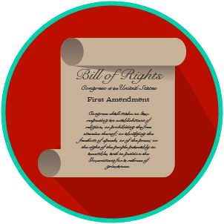
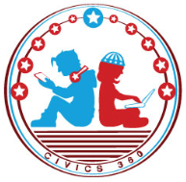
My Rights & Liberties: SS.7.CG.3.6
Voting Rights
VIDEO VIEWING GUIDE #2
Name: ________________________________

Date: _________________________________
The Impact of the Amendments Video #2
You can use this chart as a reminder while you watch the video
Amendment | Purpose
13th Amendment | Prohibited slavery
14th Amendment | Anyone born or naturalized in the US was a citizen; state governments could not pass laws that limited the rights of citizens
Equal Protection Clause of the 14th Amendment | States cannot deny equal protection to citizens
15th Amendment | States and the federal government cannot deny citizens the right to vote just because of their race
19th Amendment | States and federal government cannot deny women the right to vote
24th Amendment | Prohibited the states and federal government from charging poll taxes
26th Amendment | Lowered the national voting age from 21 to 18

Question | List Specific Evidence from the Video | Complete Sentence
1. After the 26th Amendment, who was allowed to vote?
2. How did some states respond to the passage of the 14th and 15th Amendments?

3. How could literacy tests keep you from voting?
4. How did individuals and interest group respond to states trying to limit their 14th and 15th Amendment rights?
5. Define the purpose of each of the following: | Civil Rights Act of 1964
 | Voting Rights Act of 1965
 | Civil Rights Act of 1968
6. What was the purpose of the Civil Rights Act of 1964 and the Voting Rights Act of 1965?
7. What was the goal of the Equal Rights Amendment? Did it work?
8. What was the impact of the 19th and 26th Amendments?

Scenarios | Response
1. On your 18th birthday, you go to register to vote. They tell you that you have to take a literacy test. What do you tell them and why?
2. You find out that a friend has been denied a job by a government agency simply because of who they are. They don't know what to do. What do you tell them?
3. A friend argues with you that there is really nothing that has encouraged people to participate in the political process or to protect their rights. Based on what you have learned, how can you convince her otherwise?

