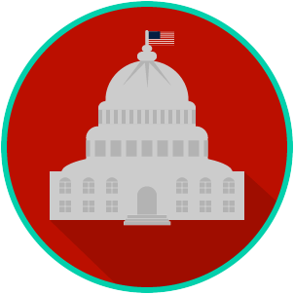
Federal Government: SS.7.CG.1.9 Limits on Government Power
Name:

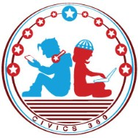
Date:

VIDEO ONE VIEWING GUIDE

Question | List Specific Evidence from the Video | Complete Sentence
1. What is the purpose of limited government?
2. What is a constitution?
3. What is the highest law of the land?
4. Why is power split into three branches?
5. Identify the role and responsibility of each of the three branches of government:
5a. Legislative:
5b. Executive:
5c. Judicial:

6. What is judicial review?
7. Define ‘separation of powers’ in your own words.
8. Define ‘checks and balances’ in your own words.
9. Provide an example of the ways in which the powers of each branch can check and balance the actions of another branch:
9a. Legislative:
9b. Executive:
9c. Judicial:
10. How do the concepts of separation of powers and checks and balances limit the power of government?

