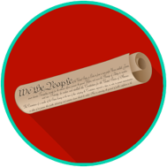
Constitutional Principles and Structures: SS.7.CG.1.9
Limits on Government Power
READING #1
Name: ________________________

Date: _________________________

SS.7.CG.1.9 Benchmark Clarification 1: Students will explain the concept of limited government in the U.S. Constitution.

This material is adapted from resources developed by the Center for Civic Education.

The Constitution includes the principle of limited government. This means that government can only do what the people allow it to do. In the United States, the government’s power is limited by a constitution, or written agreement. A constitutional government is a form of government based on a written set of laws to which all citizens agree. In this form of government, the Constitution is the highest law of the land. The Constitution limits the power of both the federal and state governments. It says what each may and may not do. A constitutional government is organized so that one person or group cannot get enough power to control the whole government.

constitutional government - a form of government based on a written set of laws that all citizens agree to; in this form of government, the constitution is the highest law of the land
limited government - a government that has been limited in power by a constitution, or written agreement

Source
Quigley, C., & Rodriguez, K. We the People: The Citizen and the Constitution. Calabasas, CA: Center for Civic Education, 2007. Print.

