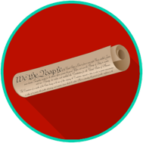
Constitutional Principles and Structures: SS.7.CG.1.9
Limits on Government Power
READING #3
Name: ________________________

Date: _________________________

SS.7.CG.1.9 Benchmark Clarification 3: Students will analyze how government power is limited by separation of powers and/or checks and balances.

This material is adapted from resources developed by the Center for Civic Education.

To keep the government from abusing its powers, the U.S. Constitution uses a separation of powers system that includes checks and balances as part of that system. The power to make, enforce, and interpret laws is separated into three different branches of government. The government is limited even more by checks and balances. This means that each branch can “check” (limit) the powers of the other two branches.

checks and balances - a principle of the federal government, according to the U.S. Constitution, that allows each branch of government to limit the power of the other branches
separation of powers - the structure of the federal government, according to the U.S. Constitution, that sets up three branches with their own distinct powers and responsibilities

Source:
Quigley, C., & Rodriguez, K. We the People: The Citizen and the Constitution. Calabasas, CA: Center for Civic Education, 2007. Print.

