****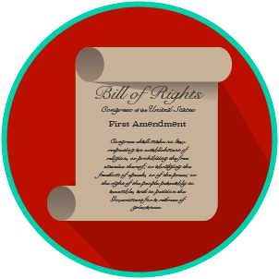

*My Rights and Liberties: SS.7.CG.3.6*

***Voting Rights***

**READING GUIDE #3**

Name: _______________________

Date: ________________________

**Reading: Voting Rights Scenarios**

**Benchmark Clarification 3:** Students will examine how these amendments increased participation in the political process.

|  |  |
| --- | --- |
| **Reading Task** | **Response** |
| What ideas are presented in the reading? |  |
| What is the central idea of the reading? |  |
| Select two words or phrases that support the central idea. |  |
| How might this reading connect to your own experience or something you have seen, read, or learned before? |  |
| How did these amendments increase participation in the political process? | These amendments increased participation in the political process by: |