How do people use art to influence democratic change?
Primary Sources
What do primary sources reveal about those seeking a voice in democracy?

- What issues or injustices are being highlighted?
- What audience is the source trying to reach?
- What evidence of civic participation or resistance appears?
- What does this source suggest about the time period?
Landmark Supreme Court Case
How do landmark Supreme Court decisions define and protect rights?

- What constitutional question did the Court need to resolve?
- How did the ruling expand or limit rights?
- What did this ruling suggest about the time period?
- How did this ruling impact previous, current, or future generations?
- What precedent was set?
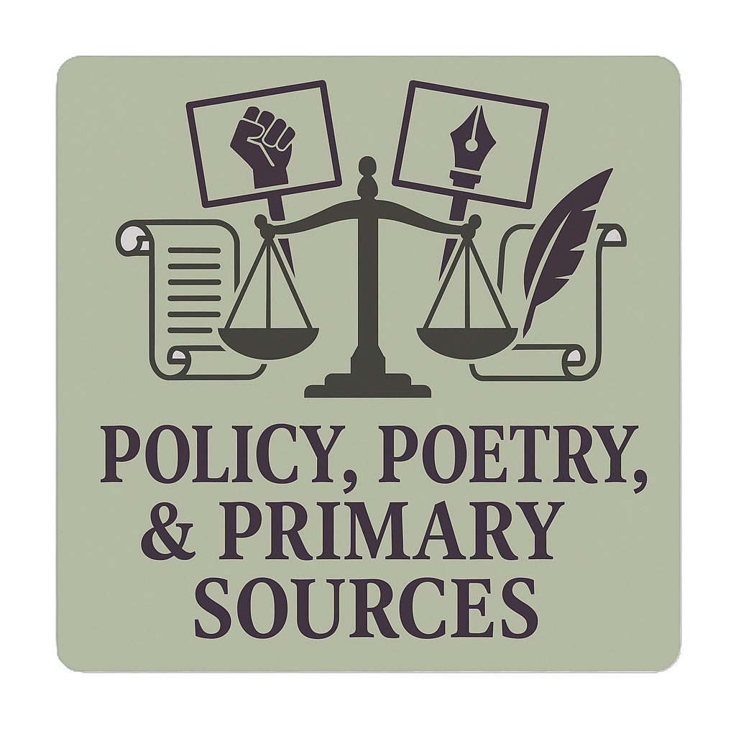
Poetry
How have poets used language to inspire social change?

- What social, political, or personal issue is the poet addressing?
- What emotions or imagery does the poet use to communicate their message?
- How does the poem model a form of civic expression?
- Which lines best connect to ideas about rights, justice, or equality?
- Which literary or rhetorical devices most strongly shaped your interpretation?
- What can poetry express that laws or court decisions can’t?
Extended Response: Pick 1
- How does the Supreme Court decision demonstrate real-world consequences of the issues identified in the poetry or primary sources?
- How do people (poets, protestors, judges) use words differently to make arguments?
- What tensions exist between emotions and law?
- Which source presents the most powerful argument for democratic change, and why?
Evidence must include:
- 1-2 lines of poetry
- 1-2 literary or rhetorical devices used
- 1-2 quotations from the landmark decision
- 1-2 pieces of evidence from the primary sources

